Manual: NewStim and RunExperiment
Location: sites.google.com/site/alexanderheimel/protocols/manual-newstim-and-runexperiment
Author: Alexander Heimel, Updated: 2021-03-10

NewStim is a set of matlab routines originally written by Steve Van Hooser to present visual stimuli, and adapted by Alexander Heimel and others. It uses the PsychToolbox (http://psychtoolbox.org/HomePage) to create and show the stimuli. The NewStim functions can be accessed from the Matlab command line. This is covered by a manual at the VHLabtools site, sites.google.com/site/vhlabtools/newstim/using-newstim.
RunExperiment is a graphical user interface (GUI) built around NewStim, also by Steve Van Hooser. It allows the user to graphically set stimulus parameters and control their presentation.

0. Document organization
Manual: NewStim and RunExperiment
0. Document organization
1. NewStim organization
Physical organization
Stimulus organization
2. Short tutorial
Starting NewStim on the remote stimulus machine
Creating a stimulus script
Changing presentation order and number of repetitions
Transfering and loading a script
Presenting a stimulus
Interrupting a stimulus presentation
Creating a script from a stimulus
Saving and loading a script or a stimulus
Testing a stimulus script locally
Making a movie from a stimulus script
3. Timing and synchronization
stims.mat file
Synchronization with electrophysiology data
3. Window glossary
Runexperiment
4. Stimuli
Stochasticgridstim
Periodicstim
5. Scripts
Periodicscript
6. Installation
Configuration
Monitor linearization / Gamma correction
Calibrating the spatial frequency
Stimulus timing issues
7. Trouble shooting
Problem: initstims does not start on remote stimulus computer, or falls back to matlab prompt directly after showing warmup stimulus.
Problem: Linux stimulus computer complains about absent NVidia driver
7. Further reading

1. NewStim organization

Physical organization
NewStim is usually set up to run on two separate computers, the so-called local host and remote stimulus machines. The user will interact with the local host to select stimuli and to start the show. The remote stimulus computer will create and show the stimuli as ordered. This separate setup will ensure that the stimulus computer can concentrate completely on showing the stimulus and therefore no unwanted breaks will occur during the stimulus presentation.

Stimulus organization
NewStim makes the distinction between a stimulus, e.g. a single drifting grating, and a script, which is a collection of stimuli, e.g. a series of drifting gratings with different directions. Any selection of stimuli can be merged into a script. Only scripts can be shown, but scripts can consist of a single stimulus.

2. Short tutorial

Starting NewStim on the remote stimulus machine
Start matlab and type
initstims
This will start a short drifting grating stimulus and will set the stimulus computer to slave mode, obeying the commands of the local host.

Starting NewStim control on the local host
Start Matlab and start RunExperiment from the matlab prompt:
runexperiment
or [Levelt lab specific] indirectly by selecting one of the experimental database like tptestdb or
ectestdb and clicking on [Stimulus].
If initstims executed properly on the remote machine, and the local and remote computers
communicate, the white Stimulus panel on the center right will show the ‘warmup’ stimulus. The
star behind ‘warmup’ indicates that the stimulus is loaded and ready to be presented.

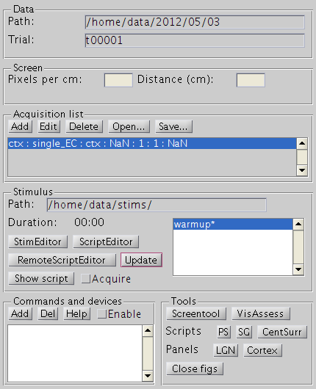

Creating a stimulus script
To make a series of drifting gratings, click on [ScriptEditor]. This opens the ScriptEditor window. Click on [New], select [periodicscript] and choose a name, e.g. ‘ps30degs’. In the figure that pops up, you can set all stimulus parameters. Most parameters are unique to each type of stimulus, but two are important for most scripts and stimuli:
Rect which is a 1x4 vector giving the location of the stimulus as [top_x top_y bottom_x bottom_y]. If you have a 1240x1024 monitor and would like to present a full screen stimulus, set Rect to [0 0 1240 1024]. If you want to show a 400x400 pixel block centered at the middle use [1240/2-200 1024/2-200 1240/2+200 1024/2+200].
Displayprefs is a cell list containing some generic display parameters. For instance {'BGpretime',1, ‘BGposttime’,2} specificies a 1s presentation of fullscreen of background color before and a 2s background after each stimulus.
For periodicscript specifically, one can, for example, change the stimulus angles to a range of 8 directions, 0:45:315, which is Matlab speak for the series 0,45,90,...,315. For more specific information on all stimulus parameters, refer to the Stimuli and Scripts sections.
After clicking [OK], the script has been added to the local script list, shown in the Script Editor.
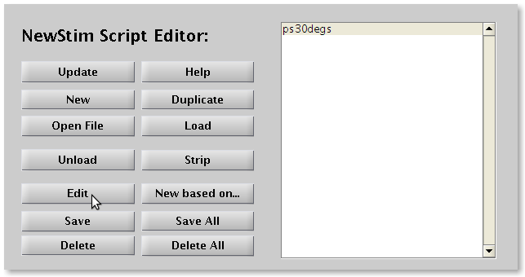

Changing presentation order and number of repetitions
Bring up the ScriptEditor, if it is not already open, by clicking [ScriptEditor] in the RunExperiment window. Select the script of interest, e.g. ps30degs from the example above. Click [Edit]. This will bring up the Editing Script window, showing a list of the individual stimuli which make up the selected script (in the case of the example, 12 gratings of different directions).
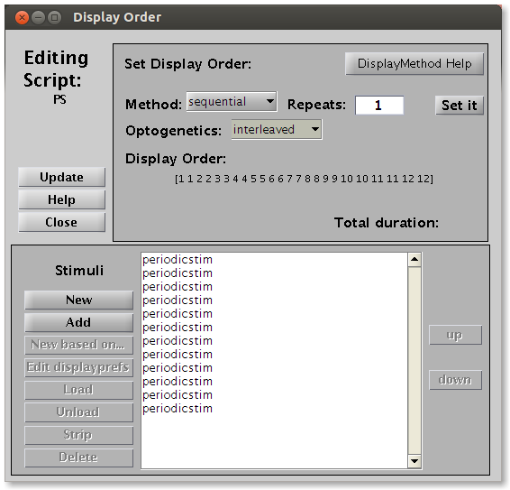
To present the stimulus multiple times, type in the number behind Repeats. Optionally change the display order method, which can be
sequential, showing them in order, i.e. 0, 30, 60 deg, etc, for our example.
random, showing for each repetition the stimuli in a random permutation.
specified, will let you select the exact presentation order
When Optogenetics is set to interleaved, each stimulus is shown twice, once without a TTL trigger and once with TTL trigger [Leveltlab only]. Other options are none, and all.
Click [Set it], and the display order will be shown between square brackets. If you are happy with the result, click [Close] to close the figure.

Transfering and loading a script
When a script is created on the local host, the remote stimulus computer will not directly know about it. The script’s parameters will need to be transferred to the remote stimulus computer. Click on [RemoteScriptEditor] in the RunExperiment window. The left panel shows all scripts on the local host. The right panel shows all scripts on the remote host. Scripts loaded into memory are followed by a star. To transfer the script and set it up for presentation, click on [-->+load]. A ‘please wait’ pop-up message will appear. This can take several seconds or up to a minute depending on the complexity of the stimulus. When the wait message disappears, your script is ready to be shown.
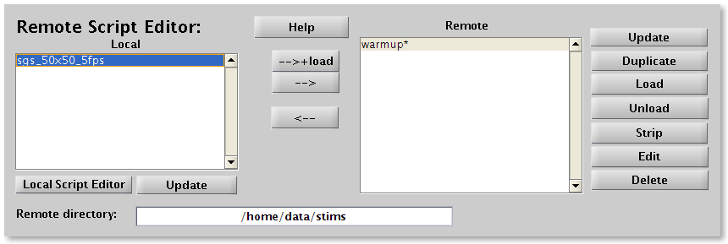

Presenting a stimulus
After the stimulus has been loaded on the remote stimulus computer, it can be shown by simply clicking [Show script] in the RunExperiment window. If the Acquire checkbox is left unchecked, no record will be kept of the stimulus presentation. If it is checked, a new folder will be created in the Path given at the top line of the RunExperiment window. This subfolder will be named the next available folder of the type t00001, and will be shown behind Trial. After the presentation is finished a file called stims.mat containing all stimulus parameters, order and presentation times will be written in this folder (see separate section on stims.mat). It is best practice to store any simultaneously acquired physiological data in the same folder.

Interrupting a stimulus presentation
On the remote stimulus computer, simultaneously press the Ctrl and ‘c’ keys several times. The stimulus window will still cover the screen and hide the Matlab prompt. To close the stimulus window, type
clear screen
followed by Enter. This should close the stimulus screen and return you to the Matlab prompt. If this fails, repeat this procedure, possibly after pressing [Alt-Tab] several times to select the Matlab window. After returning to a visible matlab prompt, either you can quit matlab by typing ‘quit’ or restart stimulus slave mode by typing ‘initstims’.

Creating a script from a stimulus
Not all stimuli come with a prepackaged script interface like the periodicscript gui that we have seen in the above example. In this case, or if you want to make a collection of stimuli ranging over a parameter which is not allowed for by the script gui, you should first create the stimuli using the StimEditor.
Suppose we want to make a script consisting of a small and a large drifting grating stimulus. First open the StimEditor by clicking on [StimEditor] in the RunExperiment window. Click on [New], select ‘periodicstim’ and name the stimulus ‘pssmall’. Choose [320-50 240-50 320+50 240+50] as the Rect and click [OK].
Next create a second, larger stimulus, by reclicking [New] in the StimEditor window, selecting ‘periodicstim’ again, and this time naming it ‘pslarge’. Choose [320-100 240-100 320+100 240+100] as Rect and click [OK].
You will see the two stimuli listed in StimEditor’s stimuli panel. Select them both (by using Shift or Ctrl keys while clicking) and click on [New Script with …] and choose a name for your script. The stimulus numbers will be correspond to their order of in the stimulus list in the StimEditor panel, not to their creation number.

Saving and loading a script or a stimulus
Stimuli and scripts can be saved for later use by using the [Save] button in the StimEditor and ScriptEditor windows, respectively. Not surprisingly, with the [Load] button you can load previously saved stimuli and scripts.

Testing a stimulus script locally
When you have created a stimulus script with the ScriptEditor or by invoking e.g. periodicscript(‘graphical’) or periodicscript(‘default’) from the Matlab prompt, you may sometimes would like to test the script locally. Before you can do this, make sure to you have once ran NewStimInit. This creates a matlab file called NewStimConfiguration, if it did not already exist. After it is created, edit the file by typing:
edit NewStimConfiguration
and edit the two lines containing StimComputer and StimDebug parameters to read:
StimComputer = 1; % is this a stimulus computer?
StimDebug = 1;
This you will only have to do once. The StimDebug = 1 option will make the stimulus appear in a 640x480 window. This avoids the stimulus window to fill your entire desktop, so that you can continue to see the matlab command window.
If your script (created by the ScriptEditor) is called ‘testscript’, you can do this by typing
NSLoadAndRunTest(testscript)
If you would like to test the default stimulus of a certain stimulus class, e.g. periodicstim, you need to type
NSLoadAndRunTest(‘periodicstim’)

Making a movie from a stimulus script
When you would like to show you stimulus in a presentation, it is easier to have a prepared movie, than to run NewStim. You can make a quicktime movie from a script, from example named ‘testscript’ by typing
NSCaptureMovie( testscript)
The movie will be called ‘stimulus_movie.mov’ and will be saved on the desktop. Timing of the script should be fairly accurate, but is not guaranteed to be exact. Be prepared that the creation will take some time.

3. Timing and synchronization
For analysis, it is often crucial to match the time of the stimulus with the time of the acquired signal, beit spikes, LFP or behavioral data. This is generally accomplished by triggers sent out by the stimulus computer, just before the start of a trial or before every stimulus, but other solutions, such as triggering of the stimulus itself are also possible and implemented in NewStim. We first describe the most common setup here, which is the stimulus computer emitting a trigger and saving the times of the stimuli and the time of the trigger on the clock of the stimulus computer. Depending on NewStimConfiguration on the stimulus computer it is possible that also a trigger is send (on the same or different pin) at the start of each stimulus.

Commonly, stimuli are displayed in NewStim via the function DisplayStimScript( stimScript). If NSUseInitialSerialTrigger is true (set in the local NewStimConfiguration), this function will call
OpenStimSerial
to open the serial ports specified in NewStimConfiguration, and then flips up pin down and up.
StimSerial(StimSerialScriptOutPin,StimSerialScript,0);
WaitSecs(0.001);
StimSerial(StimSerialScriptOutPin,StimSerialScript,1);
Note that nowhere in the code currently this pin is initiated to 1, but when the warmup script is ran in initstims, the pin is left up.

When a stimulus is run by Runexperiment and the Acquire check box is checked. A file
stims.mat is written in the folder indicated by Path and Trial in the Runexperiment window.

Note that the NewStim code also contains functions for a more complex and adaptable sequence of Triggers, via the StimTriggerAct function. Currently this code is not in use and would need to be checked before it can be applied.

stims.mat file
The stims.mat file that is saved after the stimulus is presented contains
MTI2: {n_stimuli} struct with stimulus display information, among this
preBGframes: 240 % number of frames for preBG time
postBGframes: 0 % number of frames for preBG time
frameTimes: [1x120 double] % not including pre and postBG times
startStopTimes: [1.3645e+09 1.3645e+09 1.3645e+09 1.3645e+09] %
stimid: 6 % the identity of the stimulus shown at this point in the script sequence
start: time of starting trigger in s in stimulus computer clock time
NewStimPixelsPerCm: pixels per centimeter on stimulus display
saveScript: copy of the presented script
StimWindowRefresh: refresh rate on stimulus display
NewStimViewingDistance: distance of display to subject

The startStopTimes vector is [start of BGpretime, start of stimulus, start of BGposstime (=end of stimulus), end of BGposttime], all in second in stimulus clock times.

When using InVivoTools, you can load the stims.mat file for a specific record record from a test database by
getstimsfile( record )

To retrieve the parameters of the script saveScript:
getparameters( saveScript )

To obtain a cell list of the individual stimuli:
stims = get( saveScript )
the parameters of these stimuli can be queried like:
getparameters( stims{1} )

To obtain the sequence in which the individual stimuli that made up the script were run:
getDisplayOrder( saveScript)

To see how to obtain other information from scripts or stimuli, try
methods( saveScript )
or
methods( stims{1} )

Synchronization with electrophysiology data
Any electrophysiology data that is saved in conjunction with the presentation of NewStim stimuli can be triggered by stimulus computer or can record the trigger on a separate channel along with the electrophysiology signal. The timestamps of the acquired computer, however, are following the clock of the acquisition computer and not the stimulus computer. This will result in a shift of the time and a multiplication (very close to 1), because normally the clocks on the stimulus and acquisition computer will not run exactly in sync. Currently, when ephys data is read in the timestamps of the physiology data is realigned to the starttime of the stimulus (as saved in stims.mat) and adjusted by

acquisition.time = acquisition.time *secondsmultiplier + trial_ttl_delay;

The parameters secondsmultiplier and timeshift are set in ecprocessparams.m.

3. Window glossary

Runexperiment

Data panel shows where stimulus data is saved
Path points to where the data of the presented stimuli will saved be in subfolder and will depend on the particular stimulus setup you are using. [Leveltlab: Often RunExperiment is invoked not by the command line, but by the Stimulus button in the experimental database. This will set the path to the right location for the specific experiment.] Path can be edited by the user.
Trial is the subfolder in the Path folder where information on the last presented stimulus and recorded is stored. Trial will start from t00001, but will be automatically updated whenever stimulus presentation is started and Acquire is checked to the first not-existing folder of the form ‘t%05d’, where %05d is a 5 digit number with leading zeros.

Screen panel contains information of the stimulus display.
Pixels per cm can be calculated by dividing the horizontal screen resolution by the width of the screen. Check if dividing the vertical screen resolution by the height of the screen gives the same value. If not, change the aspect ratio on the monitor or by the operating system settings. The aspect ratio is always assumed to be square for stimulus generation.
Distance is the distance of the screen to the subject’s eyes in cm.

Acquisition list contains information about the data acquisition that is done simultaneously with the stimulus presentation. [Leveltlab: This is no longer used for anything, but still required and filled in automatically by starting RunExperiment.]

Stimulus panel provides stimulus information and control
Path is read-only and shows in which local folder the communication with the remote computer takes place.
Duration is the duration of the last presented stimulus and is updated when a stimulus is shown.
The righthand panel shows all stimulus scripts which are presented on the remote computer. An asterisk behind a script shows that a stimulus is loaded, and ready to be shown.
StimEditor opens a window to create and edit stimuli
ScriptEditor opens a window to create and edit stimulus scripts
RemoteScriptEditor opens a window to sync stimulus script between the local and remote computers.
Update will update the remote script list.
Show script will prompt the remote computer to start showing the selected script.
Acquire will toggle whether a new Trial folder is created and a stims.mat file with stimulus information is stored after presentation of the stimulus.

4. Stimuli
The stimulus class is the unitary presentation element of NewStim. Example stimuli are stochasticgridstim, periodicstim, quicktimestim, centersurroundstim. Stimuli can be defined by clicking on [New] in the StimEditor window, or from the Matlab prompt by calling their name, like
ps = periodicstim(‘default’)
or
ps = periodicstim(‘graphical’)
To retrieve the stimulus parameters, use:
prms = getparameters( ps )
which can subsequently be edited, and used to create a new stimulus, e.g.
prms.orientation = [0 45 90];
ps = periodicstim( prms );
Each stimulus has a parameter dispprefs, which is a cell list, and which can be used to specify a time to show a uniform background before the stimulus and a time to show the same after stimulus presentation, e.g.
prms.dispprefs = {‘BGpretime’,2,’BGposttime’,1};

Stochasticgridstim
The stochasticgridstim is a versatile stimulus showing a checkerboard of randomly changing colors or luminances. A spike-triggered average of this stimulus can reveal the receptive field of a recorded neuron.
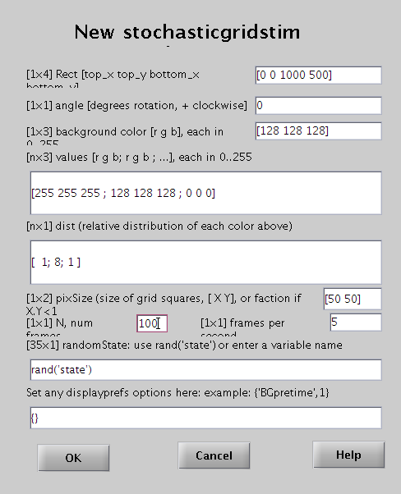

Stochasticgridstim takes the following parameters.
Rect - Location of stimulus, [top_x top_y bottom_x bottom_y] in pixels.
Angle - Rotation angle, in degrees (counterclockwise is positive).
Background color - The color of the screen not covered by the grid. [r g b], each from 0 to 255. For example, gray would be [128 128 128].
Values - Colors which may appear on the grid squares, [r g b;r g b;...], each from 0 to 255. For example, to have white, gray and black patches, choose [255 255 255;128 128 128; 0 0 0].
Dist - Relative probability distribution of each color, i.e. prob(values(i,:)) = dist(i)/sum(dist). For example, if there are three colores, and the dist = [1;8;1], the first color covers on average one tenth of the patches.
pixSize - Size of blocks x, y: [X Y] in pixels. If X and Y are less than one, then it uses that fraction of the total width and height, respectively. Note that the blocks must exactly fill up the stimulus rect.
N - Number of frames to make.
Frames per second - Speed at which to show the frames, in frames per second. The stimulus duration (apart from BGpretime and BGposttime) can be calculated by dividing the number of frames N by the frames per second rate. The optimal rate will depend on the animal, for a mouse 5 fps seems a good rate.
randState - The random state to use as the seed for generating the random numbers, for example rand('state'). See 'help rand'.
Displayprefs - Sets displayprefs fields, or use {} for default values, or for example {‘BGpretime’,1} for 1s of background color before the stimulus starts.
Type ‘help stochasticgridstim’ at the Matlab prompt for more information.
To create a stochasticgridstim script, either create a stimulus first and make a script with the stimulus, or take the shortcut by clicking [SG] in the Tools panel of the RunExperiment window.

Periodicstim
Periodicstim is a versatile stimulus for showing spatially periodic stimuli, like sinusoidal or square wave gratings. Most fieldnames speak for themselves. For orientation (better named direction), it is good to know that 0 degrees means a horizontal bar moving up and 90 degrees is a bar moving to the right.
….
Two important available features that did not yet make it into the gui, are the possibility to add two stimuli, for instance to make compound motion stimuli, and the possibility to mask a stimulus with another.

How to do this?
First create the two periodicstimuli, say ps1 and ps2. Next type at the matlab prompt:
par = getparameters(ps1);
par.ps_add = ps2; % or par.ps_mask = ps2
ps1and2 = periodicstim( par );
Next, you can update the StimEditor and create a script based on this stimulus.

…

5. Scripts
Scripts are sequences of any combination of stimuli. [Leveltlab:] When a script is started, a high-to-low TTL pulse is given by the stimulus computer, over the serial port set in the NewStimConfiguration.m file. When an optogenetics trigger is set in the NewStimScriptEditor, a high-to-low TTL pulse is given at the start of each stimulus, right before the BGpretime starts.

Periodicscript
Periodicscript is the workhorse for characterizing a neuron’s response properties using drifting gratings.
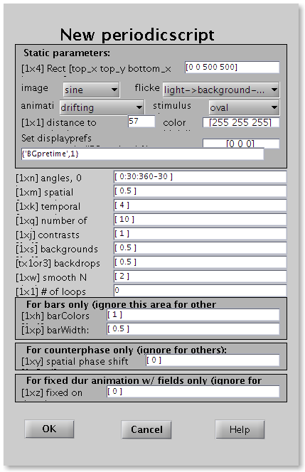
Some parameters must be identical for all stimuli within the script:
Rect - Location of stimulus, [top_x top_y bottom_x bottom_y] in pixels.
Image - Image type can be one of the following:
- field (single luminance across field)
- square (field split into light and dark halves)
- sine (smoothly varying shades)
- triangle (linear light->dark->light transition)
- lightsaw (linear light->dark transition)
- darksaw (linear dark->light transition)
- bars of width (see below)
- edge (like lightsaw but with bars determining width of saw)
- bump (bars with internal smooth dark->light->dark transition)
Animation - describes how the luminance profile will change. Can be either static, square wave, sine wave, ramp, drifting grating, fixed on-duration flicker for field stimulus.
Flicker - either light > background -> light, dark -> background -> dark, counterphase
Stimulus shape - can be either rectangle, oval, angled rect, angled oval or gaussian windowed (sigma_x=0.14 width, sigma_y=0.14*height)
Distance - distance of the monitor from the viewing subject in cm.
Color high - High intensity color, [r g b], each between 0 and 255.
Color low - Low intensity color, [r g b], each between 0 and 255.
Display prefs - Sets displayprefs fields, or use {} for default values, or for example {‘BGpretime’,1} for 1s of background color before the stimulus starts.

Other parameters can have a range of values. For each combination of these values a stimulus will be created.
Angle - direction, in degrees, 0 is up, and then clockwise.
Spatial frequency - in cycles per degrees
Temporal frequency - in Hz
Number of cycles - the number of times the stimulus should be repeated. Stimulus duration will be the number of cycles / temporal frequency.
Contrast - between 0-1: 0 is no difference from background, 1 is maximum difference.
Background - luminance of the background, ranges between 0-1, from low to high color.
Backdrop - describes the color of the area outside of display region. If [Nx1], then indicates luminance of background, 0-1 from low to high color. If [Nx3], then indicates actual RGB values to be used
Smooth N - Blurs the image with a boxcar of this pixel width
Loops - Number of forward and back loops, 0 is forward, 1 is forward and back, 2 is forward, back, and forward again, etc.
For bars only:
barColors - For bar stimuli, the color of the bars (0-1 from low color to high color)
barWidth - Width of bar (fraction of display rgn), only valid for bar stims
For counterphase stimuli only:
Phase shift - in radians (i.e. 2*pi is 1 cycle)
For fixed duration stimuli only:
Fixed on - fixed on-duration of squarewave flicker

…

6. Installation
For installation of NewStim check out the wiki of the InVivoTools repository.

Configuration
After installing matlab, psychtoolbox and the invivotools, some computer and setup specific details have to be entered. These details will be stored locally in a file called NewStimConfiguration. Start matlab and at the prompt type:
initstims
This will most probably quickly lead to an error, but it will have created a new NewStimConfiguration.m file. Edit this file by:
edit NewStimConfiguration
and go line by line over all the options and set them to match your setup and computer. You can find example configuration files by:
lookfor NewStimConfiguration
and open one of these examples for help.

For a stimulus computer make sure that:
Remote_Comm_isremote = 1;
StimComputer = 1;
StimDebug = false;
StimSerialSerialPort = 1;
NSUseInitialSerialTrigger = 1;
pixels_per_cm = 1920/92.8; % DEPENDS ON MONITOR RESOLUTION AND WIDTH

On the accompanying host computer give settings for stimulus computer, e.g.
StimWindowRefresh = 60; %Hz, usually 60 for LCD
StimWindowRect = [0 0 1920 1080];% depends on monitor
StimWindowDepth = 8; % pixeldepth

Monitor linearization / Gamma correction
Both CRT and LCD monitor have a non-linear rgb vs intensity relationship. This relationship is usually well-described by a gamma function like intensity = rgb ^ gamma, with gamma somewhere between 1 and 4. Check out http://en.wikipedia.org/wiki/Gamma_correction for more information.To be able to compare stimuli across labs, and especially to remove unwanted luminance changes when stimuli are started, monitors should be linearized. To do this, one needs a luminance meter (available from Joris Coppens at TSO, or from Maarten Kamermans). The two-photon PMTs also responds linear to light and can also be used.
First make sure that GammaCorrection is turned off, by typing in Matlab:
edit NewStimConfiguration
and checking that GammaCorrectionEnable = 0. If not, change and save, and rerun it by typing
NewStimConfiguration
Luminance of white should be adjusted to 10 cd/m2, by changing the brightness.
Run initstims and check the luminance. This will in the end cause the gray background (50% intensity) to be 5 cd/m2.
To make a calibration stimulus, the NewStim package can be used, which is the easiest way for the two-photon setup. A stimulus would be a small part in the center of the screen, with contrast 0%, shown at a range of background intensities, e.g. (0:0.1:1) for a couple of seconds. Each stimulus should be shown long enough to be able to measure the luminance.
Alternatively, and perhaps easier, you can run the Matlab script monitor_calibration from the Matlab prompt at the stimulus computer
monitor_calibration
A sequence of 11 luminances are shown and need to be measured with the luminance meter (set to cd/m2). The measurements of the luminance meter (in cd/m2) should be entered into matlab to create a gamma correction table using:
CreateGammaCorrectionTable( (0:0.1:1), [0.518 0.518 … 5.836 8.736] )
This will calculate a best fit to the data and save a gamma correction table as gct_hostname.txt in the folder with monitor calibration.
To use the table, switch on gamma correction in NewStimConfiguration and select loading of the newly created file. Open NewStimConfiguration at the matlab prompt
edit NewStimConfiguration
If a message appears, that NewStimConfiguration does not exist yet, do not create it, but select Cancel. In this case, run initstims by typing
initstims
This should create NewStimConfiguration. Next retry editing NewStimConfiguration. Search the line with GammaCorrectionEnabled and set to 1, and add or edit the following line (note the exact use of spaces.)
LoadGammaCorrectionTable([‘gct_’ host ‘.txt’]);
Save the file, and run it for the gamma correction to take effect:
NewStimConfiguration
Next, repeat the luminance measurements by typing ‘monitor_calibration’ or rerunning the script and check if the input-output relationship is now linear, by making a plot of the results:
plot( [0.718 1.512 … 7.826 8.707])

For visual checks of monitor capabilities, see http://www.lagom.nl/lcd-test/

Calibrating the spatial frequency
To present stimuli of a specified spatial frequency, the stimulus computer needs to know the number of pixels per cm on the screen and the distance of the subject to the screen. To measure the number of pixels per cm, check the resolution of the monitor (Start menu / System / Preferences / Monitor) and measure the size of the screen. Compute the values for the horizontal and vertical directions. Correct height and width if necessary to ensure pixels are square. Measure again and edit the line setting ‘pixels_per_cm’ in NewStimConfiguration by typing at the Matlab prompt:
>> edit NewStimConfiguration
Just above this line set NewStimViewingDistance to the correct value.
Rerun NewStimConfiguration, reload possible stimuli and check the spatial frequency by measuring the width of a single cycle of (static) grating stimulus.

Stimulus timing issues
Make sure all visual effects are turned off. In Ubuntu this can be done by selecting None in Taskbar: System / Preference / Appearance - Visual Effects.
For more info on timing issues, check out the faq at http://psychtoolbox.org/PsychtoolboxFaq

Two-photon computer
To calibrate timing for two-photon display, make a fullscreen 0% contrast stimulus with a background different from backdrop in NewStim and display it several times for some minutes. (e.g. timing_test.mat). Scan the monitor with the microscope as fast as possible using frame imaging. Next analyse the timing of the stimulus by clicking [PSTH] in the two-photon analysis window (while the ‘Mean’ option is unchecked). Onset timing should not jitter more than the monitor refresh rate and the microscope scan rate. Pick the time at which the response is still 0 and set this (if necessary) in tpcorrectmti.m as timeshift, by
>> edit tpcorrectmti
If the response, does not go up before say 0.100 s, than timeshift should be 0.100s. If the response is 0.100 s too early, timeshift should be -0.100s.
After the correction, check the timing again by clearing the computed data by pressing the [Clear] button and reclick [PSTH] analysis. The response should now start going up from 0s.

Electrophysiology computer
To calibrate timing for an electrophysiology setup, make a fullscreen 0% contrast stimulus with a background different from backdrop in NewStim and display it for several seconds (e.g. timing_test.mat). Take photocell (in CCD-camera box) and connect it via BNC to the spiking channel of the acquistion board (CED1401). Run the stimulus and detect spikes from the photocell signal, when the stimulus is on. Then run the analysis. Carefully check the PSTH spike rastogram to see the alignment of the spikes to the stimulus. You may need to zoom in around the stimulus start at t=0, by for example xlim([-0.02 0.02]). If the line is not perfectly straight, adjust trial_ttl_delay and secondsmultiplier in ecprocessparams.mat. And redo the analysis. No need to redo the test.

7. Trouble shooting

Problem: initstims does not start on remote stimulus computer, or falls back to matlab prompt directly after showing warmup stimulus.
Possible causes:
Computer hosting the communications folder (often the local host) is not on.
Solution: Turn computer on
Network connectivity problem. Check whether both local host and remote have internet, by for example starting a browser.
Solution: Check if cables are in. Switch UTP ports.
Call IT.

Diagonistics:
Check if DHCP server is working normally.
On linux: in terminal, type ifconfig
the start of the resulting info should be:

eth0 Link encap:Ethernet HWaddr d4:be:d9:4f:80:1c
inet addr:192.87.10.119 Bcast:192.87.11.255 Mask:255.255.254.0

where inet addr, depends on the specific pc. If inet adrr (the ip-address) does not start with 192.87, somebody in the corridor installed his own wireless router.

On Windows: run command.com and in the terminal type netstat.
The output should be like
Proto Local Address
TCP 192.87.10.152:49174 …
where the number depends on the pc. If the local address (the ip-address) does not start with 192.87, somebody in the corridor installed his own wireless router.

Check if the DNS (domain name server) is working properly:
On linux and windoss: in terminal or command window (opened by running command.com), enter
ping imap.herseninstituut.knaw.nl
which should result in something like
PING pop.herseninstituut.knaw.nl (194.171.152.10) 56(84) bytes of data.
64 bytes from pop.herseninstituut.knaw.nl (194.171.152.10): icmp_req=1 ttl=63 time=1.25 ms
64 bytes from pop.herseninstituut.knaw.nl (194.171.152.10): icmp_req=2 ttl=63 time=1.36 ms
if it doesn’t, try
ping 194.171.152.10
if that does work, then the DNS is not functioning properly.

On linux: You can bypass the DNS by adding a line with hostname and ip combination in /etc/hosts, by running from a terminal
sudo gedit /etc/hosts
and adding a line like
192.87.10.152 daneel.herseninstituut.nin.knaw.nl
where the ip adress of the host can be checked as above.

Problem: Linux stimulus computer complains about absent NVidia driver
Possible cause:
Linux kernel was updated
Solution: reinstall driver
# first kill X-windows
# go to text mode: Ctrl-Alt-F2
# Log in as dataman
ps -aux|grep gdm
# to find job gdm job number #jn
sudo kill #jn (INSERT jobnumber for #jn)
# reinstall driver:
cd /mnt/MVP/Common/InVivo/Drivers/Nvidia_linux/
sudo NVIDIA-Linux-x86-290.10.run

7. Further reading
PsychToolbox tutorial: http://psychtoolbox.org/PsychtoolboxTutorial.
Use ‘help’ for any of the stimuli or scripts at the Matlab prompt, e.g. ‘help periodicscript’.

